auto enp0s8

iface enp0s8 inet static

address 192.168.48.101

netmask 255.255.255.0

auto enp0s3

01964

10.0.2.15

10.0.2.3

0 1777617249

192.168.23.101

255.255.255.0

To check ip address win+r ncpa.cpl

Which means control panel -> All Control Panel Items -> Network Connections

Enp0s8

192.168.199.101

255.255.255.0

At the beginning was having issues with static ip to access resources at my vboxsf_mylib later

Added the ip address to sudoedit sites-available/vboxsf.conf

And ports.conf then things became alright dated 19-01-2021

However I spent several days to resolve the issue my gratefulness to Allah Almighty

In linux configuration files are stored at etc directory

sudo apt-get install linux-image-generic-lts-xenial linux-generic-lst-xenial

sudo apt-get install build-essential virtualbox-dkms nano zip unzip curl man-db acpid git module-assistant

sudo reboot

*insert guest addition cd image*

man mount

ls -la /dev

ls -la /dev | grep cdrom

ls -la /media/cdrom

sudo mount /dev/cdrom /media/cdrom

ls -la /media/cdrom

sudo sh /media/cdrom/VBoxLinuxAdditions.run --nox11

sudo reboot

lsmod

lsmod | grep vbox

ls -la /media

cd /media/sf_sandbox

cd /media/sf_mylib

-bash: cd: /media/sf_sandbox: Permission denied

id

uid=1000(masum) gid=1000(masum) groups=1000(masum),4(adm),24(cdrom),27(sudo),30(dip),46(plugdev),113(lpadmin),114(sambashare)

getent group vboxsf

vboxsf:x:999:

dspace@mylib:~$ getent group vboxsf

vboxsf:x:126:dspace

sudo usermod -a -G vboxsf masum

cd /media/sf_sandbox

-bash: cd: /media/sf_sandbox: Permission denied

cd /media/sf_sandbox

masum@sandbox:/media/sf_sandbox$

id www-data

uid=33(www-data) gid=33(www-data) groups=33(www-data)

sudo usermod -a -G vboxsf www-data [ *this is to give apache user group to access shared folder*]

masum@sandbox:/media/sf_sandbox$ cd /etc

masum@sandbox:/etc$

192.168.231.101

ls -1

masum@sandbox:/etc$ ls -1 | grep apache

masum@sandbox:/etc$ cd apache2

ls –la

masum@sandbox:/etc/apache2$ ls -la sites-available

total 20

masum@sandbox:/etc/apache2$ ls -la sites-enabled

sudoedit sites-available/vboxsf.conf

01964 512

//<VirtualHost *10.0.2.15:80 * 10.0.2.15:8080>

<VirtualHost *192.168.48.101:80 * 192.168.48.101:8080>

ServerName sandbox

ServerAlias *. sandbox

LogLevel info

ErrorLog ${APACHE_LOG_DIR}/vboxsf-error.log

CustomLog ${APACHE_LOG_DIR}/vboxsf-access.log combined

RewriteEngine On

<Directory />

Options FollowSymLinks

AllowOverride All

</Directory>

<Directory /media/>

Order allow,deny

Allow from all

Require all granted

</Directory>

<Location /server-status>

SetHandler server-status

Order allow,deny

Allow from all

Require all granted

</Location>

UseCanonicalName Off

VirtualDocumentRoot /media/sf_%1

</VirtualHost>

DocumentRoot /var/www/html

sudoedit ports.conf

# If you just change the port or add more ports here, you will likely also

# have to change the VirtualHost statement in

# /etc/apache2/sites-enabled/000-default.conf

Listen 192.168.48.101:80

Listen 192.168.48.101:8080

<IfModule ssl_module>

Listen 443

</IfModule>

<IfModule mod_gnutls.c>

Listen 443

</IfModule>

# vim: syntax=apache ts=4 sw=4 sts=4 sr noet

go to exercise file open up the configuration copy and paste

8080

sudoedit ports.conf

masum@sandbox:/etc/apache2$ sudo a2ensite vboxsf

output

Enabling site vboxsf.

To activate the new configuration, you need to run:

service apache2 reload

masum@sandbox:/etc/apache2$ sudo a2dissite 000-default

masum@sandbox:/etc/apache2$ sudo a2enmod rewrite vhost_alias

sudo service apache2 restart

test server <http://sandbox.dev:8080/server-status>

<http://sandbox.dev:8080/errors.php>

[masum@sandbox:/etc/php/7.0$](mailto:masum@sandbox:/etc/php/7.0$)

ls –la

drwxr-xr-x 5 root root 4096 Oct 3 22:57 .

drwxr-xr-x 3 root root 4096 Oct 3 22:57 ..

drwxr-xr-x 3 root root 4096 Oct 3 22:59 apache2

drwxr-xr-x 3 root root 4096 Oct 3 22:59 cli

drwxr-xr-x 2 root root 4096 Oct 3 23:00 mods-available

masum@sandbox:/etc/php/7.0$ ls -la cli

masum@sandbox:/etc/php/7.0$ less cli/php.ini

masum@sandbox:/etc/php/7.0$ ls -la cli/conf.d

masum@sandbox:/etc/php/7.0$ ls -la apache2

masum@sandbox:/etc/php/7.0$ ls -la apache2/conf.d

create a new file

masum@sandbox:/etc/php/7.0$ sudoedit /etc/php/7.0/mods-available/phpcustom.ini

extension=mcrypt.so

; Custom shared config

; priority=01

error_reporting=E_All

display_errors=On

display_startup_errors=On

error_log=/var/log/php_errors.log

log_errors_max_len=0

memory_limit=256M

post_max_size=100M

upload_max_filesize=100M

ctrl+x to exit

then y to save and press enter

masum@sandbox:/etc/php/7.0$ sudo phpenmod phpcustom

masum@sandbox:/etc/php/7.0$ phpquery -v 7.0 -s apache2 –M

masum@sandbox:/etc/php/7.0$ sudo touch /var/log/php_errors.log

masum@sandbox:/etc/php/7.0$ sudo chown www-data: /var/log/php_errors.log

masum@sandbox:/etc/php/7.0$ sudo apt-get install php-mcrypt php-intl php-sqlite3 php-mbstring php-xml php-gd –y

masum@sandbox:/etc/php/7.0$ sudo phpenmod mbstring simplexml

to fix error

run the following yellow command

# Check version php and pecl

|  |
| --- |
| # |
| php -v # if default php is not 7.0 then use /usr/bin/php7.2 instead php |
| pecl version |
| sudo apt-get install php-pear |
| sudo apt-get install php7.0-dev |
|  |
|  |  |
|  |  |
|  |  |
|  |  |
|  |  |

sudo apt-get install php7.0-dev

if the error persist run the following command and later continue with server development script

sudo apt-get install php-xml php7.0-xml

you may run he following command too

sudo apt-get -y install gcc make autoconf libc-dev pkg-config

sudo apt-get -y install libmcrypt-dev

sudo pecl install mcrypt-1.0.1

run

php -i | grep mcrypt

grep "extension=mcrypt.so" /etc/php7.0/cli/php.ini

and

grep "extension=mcrypt.so" /etc/php7.0/cli/conf.d/mcrypt.ini

If the two command return the same thing : “extension=mcrypt.so”, this means the extension is included two times.

The solution is simple, juste remove one of these configuration, that will be ok.

Somehow I find two php 7.0 and 8.0 I removed 8.0 php.ini

masum@sandbox:/etc/php/7.0$ sudo service apache2 restart

masum@sandbox:/etc/php/7.0$ tail /var/log/php_errors.log

instead sudo cat /var/log/apache2/error.log this will show the error message

tail: cannot open '/var/log/php_errors.log' for reading: No such file or directory

; Custom share config

; priority=01

Error_reporting=E_All

Display_errors=On

Display_startup_errors=On

Error_log=var/log/php_errors.log

Log_errors_max_len=0

Memory_limit=256M

Post_max_size=100M

Upload_max_files=100M

masum@sandbox:/etc/php/7.0$ sudo touch /var/log/php_errors.log

masum@sandbox:/etc/php/7.0$ sudo chown www-data: /var/log/php_errors.log

masum@sandbox:/etc/php/7.0$ sudo apt-get install php-mcrypt php-intl php-sqlite3 php-mbstring php-xml php-gd –y

masum@sandbox:/etc/php/7.0$ sudo phpenmod mbstring simplexml

masum@sandbox:/etc/php/7.0$ sudo service apache2 restart

8081

Mail Catcher

masum@sandbox:~$ sudo apt-get install libsqlite3-dev ruby-dev –y

masum@sandbox:~$ sudo gem install mailcatcher

mailcatcher –help

Ubuntu deals a systemd a system and service manager example – SSH and apache are controlled by system

sudoedit /lib/systemd/system/mailcatcher.service

[Unit]

Description=MailCatcher Service

[Service]

Type=simple

ExecStart=/usr/local/bin/mailcatcher --foreground --ip 0.0.0.0

[Install]

WantedBy=multi-user.target

sudo service mailcatcher start

sudo systemctl enable mailcatcher.service

sudo service mailcatcher status

PHP and Mail Catcher

Catchmail- routes mail to Mailcatcher

PHP-send_mail

sudoedit /etc/php/7.0/mods-available/mailcatcher.ini

sendmail_path = /usr/local/bin/catchmail

sendmail_from = [mailcatcher@sandbox.dev](mailto:mailcatcher@sandbox.dev)

sendmail_path = /usr/local/bin/catchmail

sendmail_from = mailcatcher@mylib

sudo phpenmod mailcatcher

sudo service apache2 restart

php -i | grep sendmail

masum@sandbox:/etc/php/7.0$ php -a

Interactive mode enabled

php > mail('target@example.com', 'First Test Email', 'Yes, This is Billaha', 'From:source@example.com’);

use apt to upgrade and install packages

installed virtualbox guest additions

explored linux users and group permissions

configured apache http server

manage apache sites and modules

tuned php for development

installed MailCatcher as a service

Installing and configuring mysql

sudoedit /etc/php/7.0$ sudoedit /etc/mysql/mysql.cnf

press escape + front slash to reach the end of the file

[mysqld]

collation-server = utf8_unicode-ci

character-set-server = utf8

bind-address = 0.0.0.0

slow_query_log = 1

slow_query_log_file = /var/log/mysql/slow.log

long_query_time = 2

sudo service mysql restart

cd /var/log/mysql

mysql sloq.log was not returned

masum@sandbox:/var/log/mysql$ cat tail error.log

working

masum@sandbox:/var/log/mysql$ tail error.log

this also working

error.log is in the admin group, how do we change this enter chg rp command it changes group ownership of a file

we will change the group of a slow file that we can access

masum@sandbox:/var/log/mysql$ sudo chgrp adm slow.log

tail slow.log

MySQL prilivilages

It is special right available only to a particular person

MySQL access control uses privileges

Where users granted privileges to access resources,

MySQL refers privileges and storage as grant

Dozens of privileges mirror data definition and manipulation

Example privilege to allow select

masum@sandbox:/var/log/mysql$ mysql uroot -proot

mysql: [Warning] Using a password on the command line interface can be insecure

in my machine it dodn’t work the following one worked

masum@sandbox:/var/log/mysql$ mysql -u root –p

mysql -uroot -proot

mysql> SELECT host FROM mysql.user WHERE user='root';

UPDATE mysql.user SET host='%' WHERE user='root' AND host='localhost';

mysql> FLUSH PRIVILEGES;

view table and change privileges according to the video

now install mysql workbench according to the video

open mysql workbench create a new schema clicking the database icon when hovering shows create new schema click it and name it as worpress all lower case when complete click aply, will be prompted to see the change when ready click apply, the result will be shown and the database has been created.

We need to also create the wordpress user, go back to user and privileges then click add account, specify the login name as wordpress and password wordpress and confirm the password, to give access to the wordpress user to the wordpress schema click schema privileges, mysql doesn’t reloads grants automatically this is example of that go down to add entry under selecting schema specify wordpress from the dropdown, click ok and then give all the access byclicking select all. Then click apply and the user is cratd.

For the remaining users and databases lets create them manually using sandbox-user.sql file in the excecise file.

MySQL statements

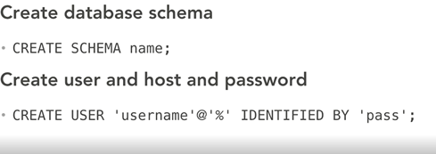

This third will grant privileges

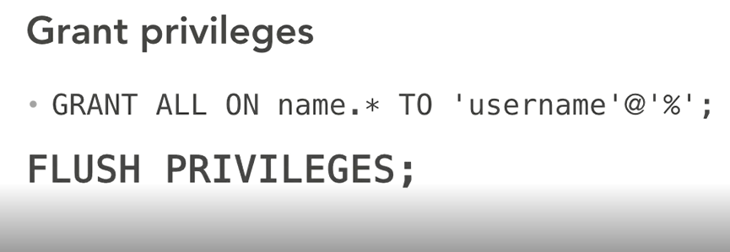

From the mysql workbench wundow click the mysql open folder-> exercise file -> mysql and sandbox user.sql

All the queries are ready to run, if youre ready click the lightening bolt up toward the left , at the bottom of the screen the action outputs =displays the result.

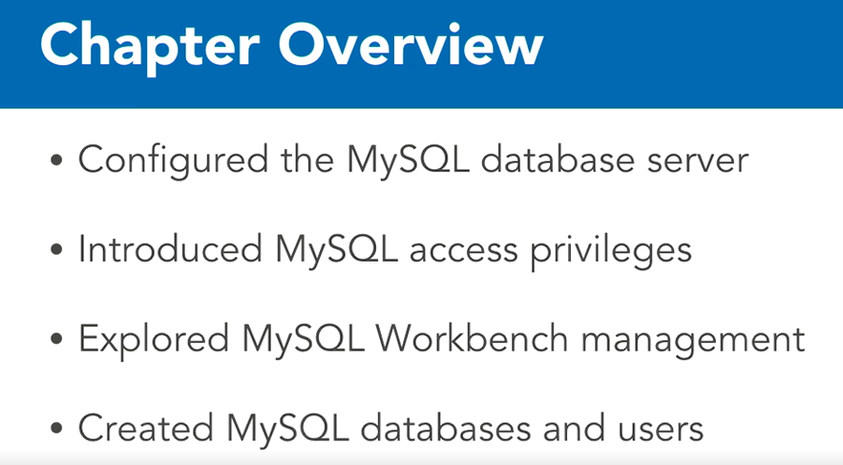

Install some debugging and performance oriented services to make it as a powerhouse,

Make it bug free.

We will install xdebug –debugging and profiling

Webgrind xdebug front end

Next we will turn the services that will inmprove performance.

We will install memcache a popular memory caching services

Install redis an inmemory database

Both memcached and redis make your site faster

But the can be used as a caching back end and more

The both provide similar core services but each has own advantages and disavantages and own capabilities.

Both are stable production ready and scalable, functionally they stay on the same server without conflict.

Practically you can choose one or the other based on your applicaiton.

PHP Accelerators

Windows cache extension for PHP as we are not using Internet Information Services (IIS) its not a good fit.

Then it leaves ZEND OpCache it already installed because it already been shipping with php with version 5.5

**Install xdebug**

masum@sandbox:~$ sudo apt-get install php-xdebug

sudo service apache2 restart

masum@sandbox:~$ sudo phpdismod xdebug

sudo service apache2 restart

masum@sandbox:~$ sudo phpenmod xdebug

sudo service apache2 restart

masum@sandbox:~$ sudoedit /etc/php/7.0/mods-available/xdebug.ini

add this two line below zend extension =xdebug.so

xdebug.profiler_enable_trigger = 1

xdebug.profiler_output_dir = /tmp/cachegrind

masum@sandbox:~$ mkdir /tmp/cachegrind

sudo chown www-data: /tmp/cachegrind

sudo service apache2 restart

Now install webgrind

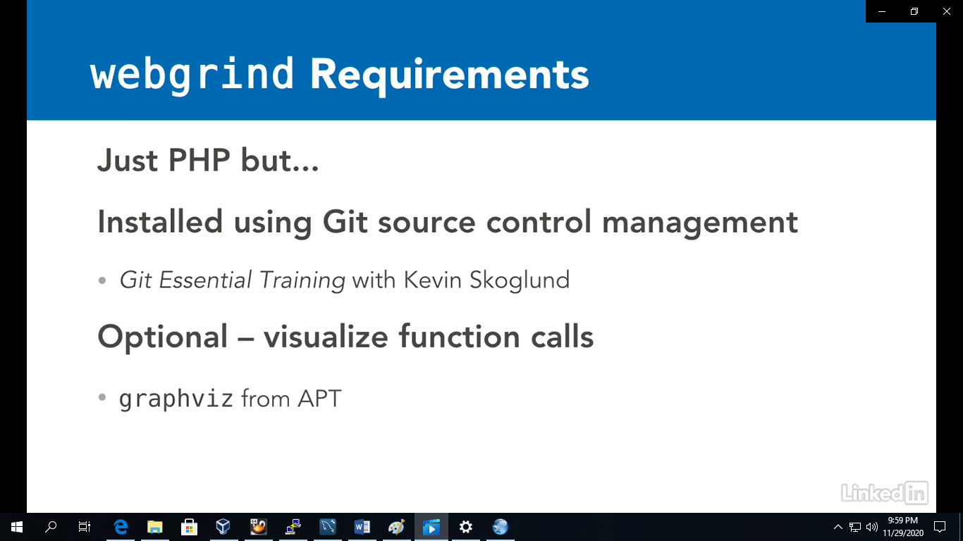

masum@sandbox:~$ sudo apt-get install graphviz

masum@mylib:/media/sf_mylib$ git clone <https://github.com/jokkedk/webgrind.git>

now got to your shared folder -> webgrind -> config.php

set as it is below

static $checkVersion = true;

static $hideWebgrindProfiles = false;

static $storageDir = '';

static $profilerDir = '/tmp/cachegrind';

masum@sandbox:~$ cd /media/sf_sandbox

http://mylib:8080/webgrind/?XDEBUG_PROFILE=1

upon enmod xdebug <http://mylib:8080/webgrind/> shall show detail graphql and so on

xdebug can slow down the server that is why by default it is disabled

masum@sandbox:/media/sf_sandbox$ sudo phpdismod xdebug

sudo service apache2 restart

**Install in-memory caching system**

Memcached is free, open source memory caching system, supported by every php application and frameworks

Default port -11211

sudo apt-get install memcached php-memcached –y

sudo service apache2 restart

to verify memcache is working

echo “stats”

php –i | grep memcached

if you like to make any configuration changs go to /etc/memcached.conf

sudoedit /etc/memcached.conf

sudo service memcached restart

memcached didn’t work correctly on mylib static ip

Install redis

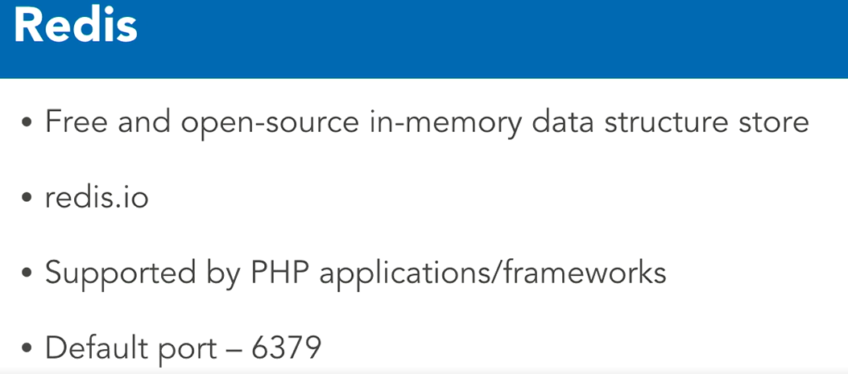

sudo apt-get install redis-server php-redis -y

sudo service apache2 restart

verify whether redis is available

php –i | grep redis

while it is available connect it to the command line client

redis-cli

[typr] info [to get server information]

when complete just type exit and press enter

configuration file /etc/redis/redis.conf

if you update the configuration

sudo service redis-server restart

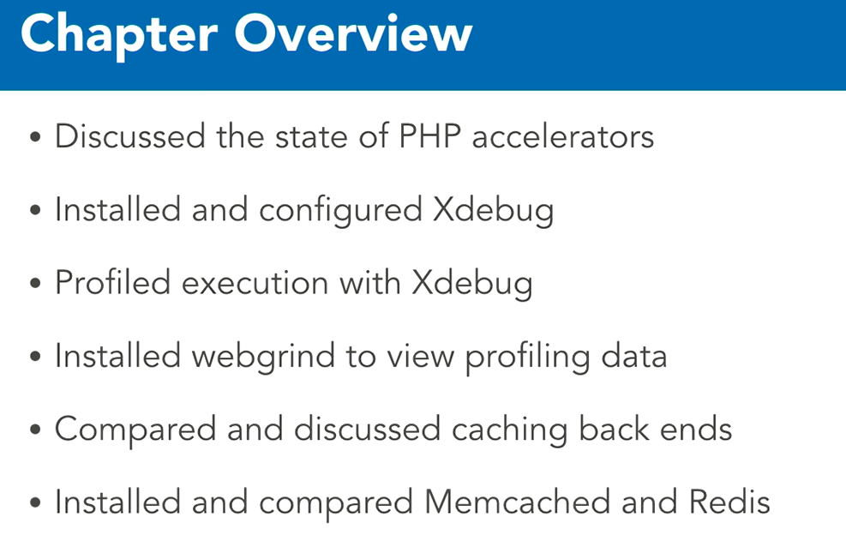

masum@sandbox:~$ cd /media/sf_sandbox

masum@sandbox:/media/sf_sandbox$ ./composer.sh

masum@sandbox:/media/sf_sandbox$ ls -la composer.phar

-rwxrwx--- 1 root vboxsf 2196512 Nov 29 23:27 composer.phar

masum@sandbox:/media/sf_sandbox$ sudo mv composer.phar /usr/local/bin/composer

masum@sandbox:/media/sf_sandbox$ composer about

masum@sandbox:/media/sf_sandbox$ composer help

for the available command

masum@sandbox:/media/sf_sandbox$ composer list

cURL version: missing, using php streams fallback, which reduces performance

zip extension: not loaded

**WordPress command line interface**

Wl-cli.org , to help with installation we are going to use three new commands

The first is wget which downloads file form a network

The second is tar archiving and extracting file.

We are going to extract contents of a downloaded file

The final command is rm which removes file

masum@sandbox:/media/sf_sandbox$ wget <https://wordpress.org/latest.tar.gz>

masum@sandbox:/media/sf_sandbox$ tar -xzvf latest.tar.gz

masum@sandbox:/media/sf_sandbox$ rm latest.tar.gz

check browser sandbox.dev:8080/wordpress

masum@sandbox:/media/sf_sandbox$ wget https://raw.githubusercontent.com/wp-cli/builds/gh-pages/phar/wp-cli.phar

masum@sandbox:/media/sf_sandbox$ sudo mv wp-cli.phar /usr/local/bin/wp

lets see cli in action

masum@sandbox:/media/sf_sandbox$ cd wordpress

masum@sandbox:/media/sf_sandbox$ wp

press arrow key to up and done when done press q to exit

lets see available themes

masum@sandbox:/media/sf_sandbox$ wp theme list

masum@sandbox:/media/sf_sandbox$ wp help

Installingwordpress

masum@sandbox:/media/sf_sandbox$ wget <https://ftp.drupal.org/files/projects/drupal-8.3.2.zip>

unzip drupal-8.3.2.zip

mv drupal-8.3.2 drupal

rm drupal-8.3.2.zip

cd drupal

<https://github.com/composer/composer/blob/master/CHANGELOG.md#200--2020->

Installed drush with super user

self-update composer --no-plugins

masum@sandbox:/media/sf_sandbox$ sudo composer require drush/drush

masum@sandbox:/media/sf_sandbox$ composer require drupal/console:~1.0 --prefer-dist --optimizer-autoloader

sudo mount -t vboxsf -o gid=dspace uid=1000,rw mylib /media/sf_mylib

composer.json

{

"require": {

"drush/drush": "^9.7"

}

}